Asset Management
Preliminary Climate Vulnerability Assessment: (Community Name)
Objective
The purpose of this worksheet is to guide you in initiating a discussion and documentation of your community’s climate vulnerabilities. In other words, identifying what could happen to interrupt your ability to deliver essential and relied upon services to your community. This can be used to inform how you will tackle priority areas where you’re vulnerable.
Process
The activity is described below, and consists of 6 steps:
- Collective Knowledge
- Local Climate Change Data
- Exposure to Climate Hazards
- Potential Vulnerabilities to Climate Hazards
- Adaptive Capacity
- Action Plan to Address Vulnerabilities
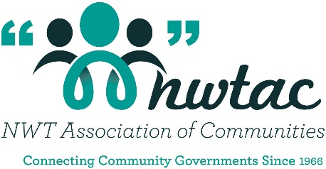
This activity should be undertaken as a group to realize the maximum benefit. It can be a quick 1-2h conversation to begin with, or it could be a more in-depth discussion over multiple days. The level of effort and depth will depend on your community’s needs and capacity. Even a short conversation can have a big impact on your group’s shared understanding of the community’s climate vulnerabilities.

- Collective Knowledge
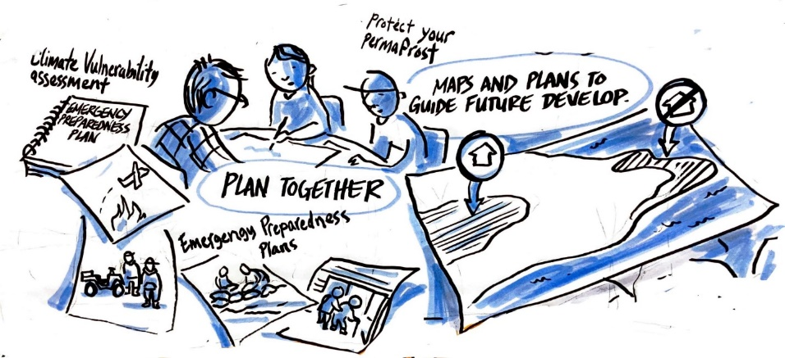
This step involves identifying a group of people who collectively bring knowledge about your community’s services, infrastructure, challenges and needs. Engaging decision makers as well as operators and community knowledge holders will provide the greatest depth of discussion and also result in a higher likelihood that action can be taken.
Participants: ___________________________ ___________________________ ___________________________
___________________________ ___________________________ ___________________________
___________________________ ___________________________ ___________________________
- Local Climate Change Data
This step involves understanding the local situation, and in particular the climate hazards your community experiences.
Documents available to understand the local climate situation:
- Climate change report (note: each community has a climate change profile which can be accessed here: Climate Change (toolkitnwtac.com))
- Northern Communities Guide on Integrating Climate Change Measures into Municipal Planning and Decision Making (note: pages 12-14 of which is part of NWTAC’s climate change toolkit and can be accessed here: climate-change-toolkit.pdf (toolkitnwtac.com))
- Other ____________________
Climate threats/hazards relevant to your community:
- Permafrost Thaw
- Heavier Snow
- Extreme Weather
- Flooding
- Drought
- Lower Water Levels
- Coastal or River Erosion
- Sea Level Rise
- Storm Surges
- Wildfires
- Plateau Shrinkage
- Species Migration
- Thinner Ice
- Other ____________________
- Exposure to Climate Hazards
This step involves identifying which infrastructure systems or services would be impacted in some way by local hazards. What are the threats your community is dealing with, or expects to deal with in the future?
To begin, use the table below as a template to list the services or systems you’re dealing with. For each of the climate hazards identified above, go through each service or system individually to determine which services could be interrupted, or which systems could be affected.
Services or Systems Exposed to Climate Hazards
Services/Systems | Climate  Hazard 1 | Climate  Hazard 2 | Climate  Hazard 3 | Climate  Hazard 4 | Climate  … | Notes
[eg. Roadways] | ✓ |  |  |  |  | [eg. Thin ice cutting off winter access to community]
 |  | ✓

What is the most immediate threat to the community: ___________________________________________________
- Potential Vulnerabilities to Climate Hazards
This step involves evaluating how the infrastructure systems or services are, or could be affected, and to what degree.
Give everyone in the group a pad of sticky notes. On a wall, add a section for each climate hazard. As a group, start with your first service or system. Give everyone a chance to write down on their own sticky notes:
- how the system or service has been affected by that hazard (i.e. what are the consequences or impacts that have been experienced)
- any additional impacts they think will occur in the future (i.e. will this become an even bigger issue, and what are the consequences)
Take pictures or have someone recording the discussion. Then clear the walls and move onto your next service or system.
Note: If you want to take this a step further, you could translate this into a formal risk matrix. There are plenty of examples and processes that can be used as a starting point. A very simple 3x3 matrix is included on page 32 of the Northern Communities Guide on Integrating Climate Change Measures into Municipal Planning and Decision Making which is part of NWTAC’s climate change toolkit: climate-change-toolkit.pdf (toolkitnwtac.com))
- Adaptive Capacity
This step involves determining what measures have, or can be, put into place to reduce the potential impact from each hazard (for each service area or system). It’s also helpful to identify whether potential measures can be done easily (and for a low cost) or if they are long term (and likely more expensive) solutions. These don’t have to be capital projects. They could be, for example, other typically lower cost and more immediate measures such as:
- Operations and maintenance activities (eg. maintaining firebreaks);
- Policies or resolutions (eg. the resolutions such as climate adaptation starting on slide 40 of the NWTAC’s Climate Change Strategic Plan (2019): NWTAC-Climate-Change-Strategic-Plan-June-20-2019.pdf (toolkitnwtac.com)
- Emergency plans (including testing scenarios based on the vulnerabilities identified for your community)
- Education and outreach (external as well as within your local government)
- Capacity building or partnerships (eg. with an educational institution perhaps to better understand impacts from permfrost, or a neighbor that has similar resource needs or issues)
- Further studies to better understand particular issues, or to evaluate potential options that may lead to capital works that assist in becoming more resilient
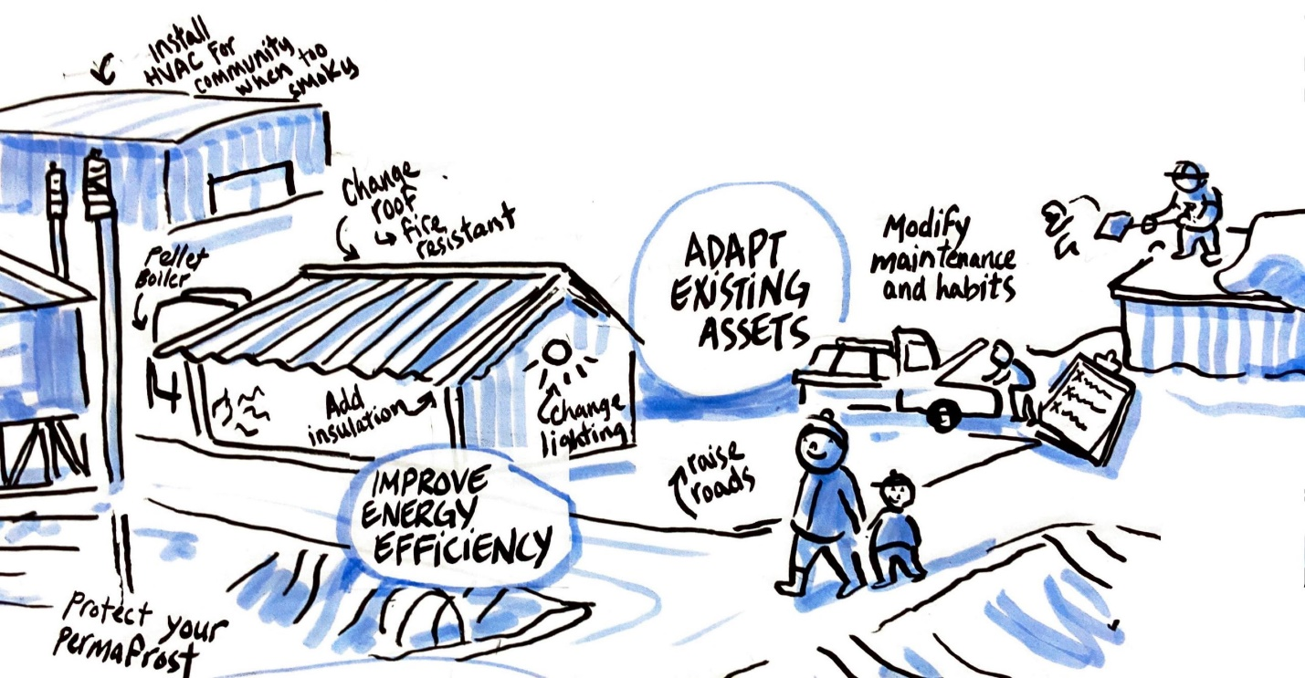
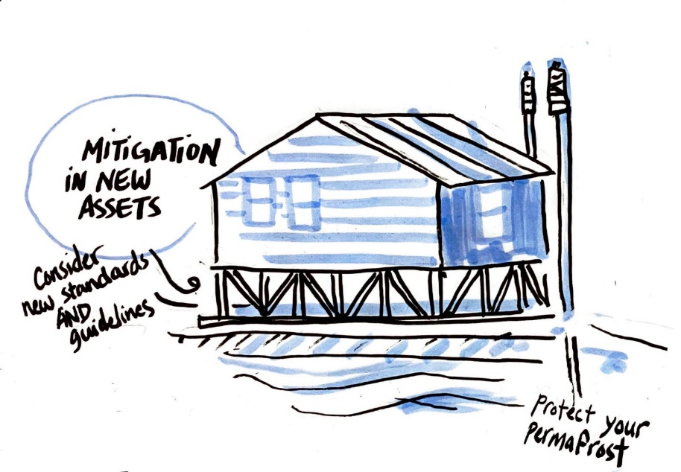
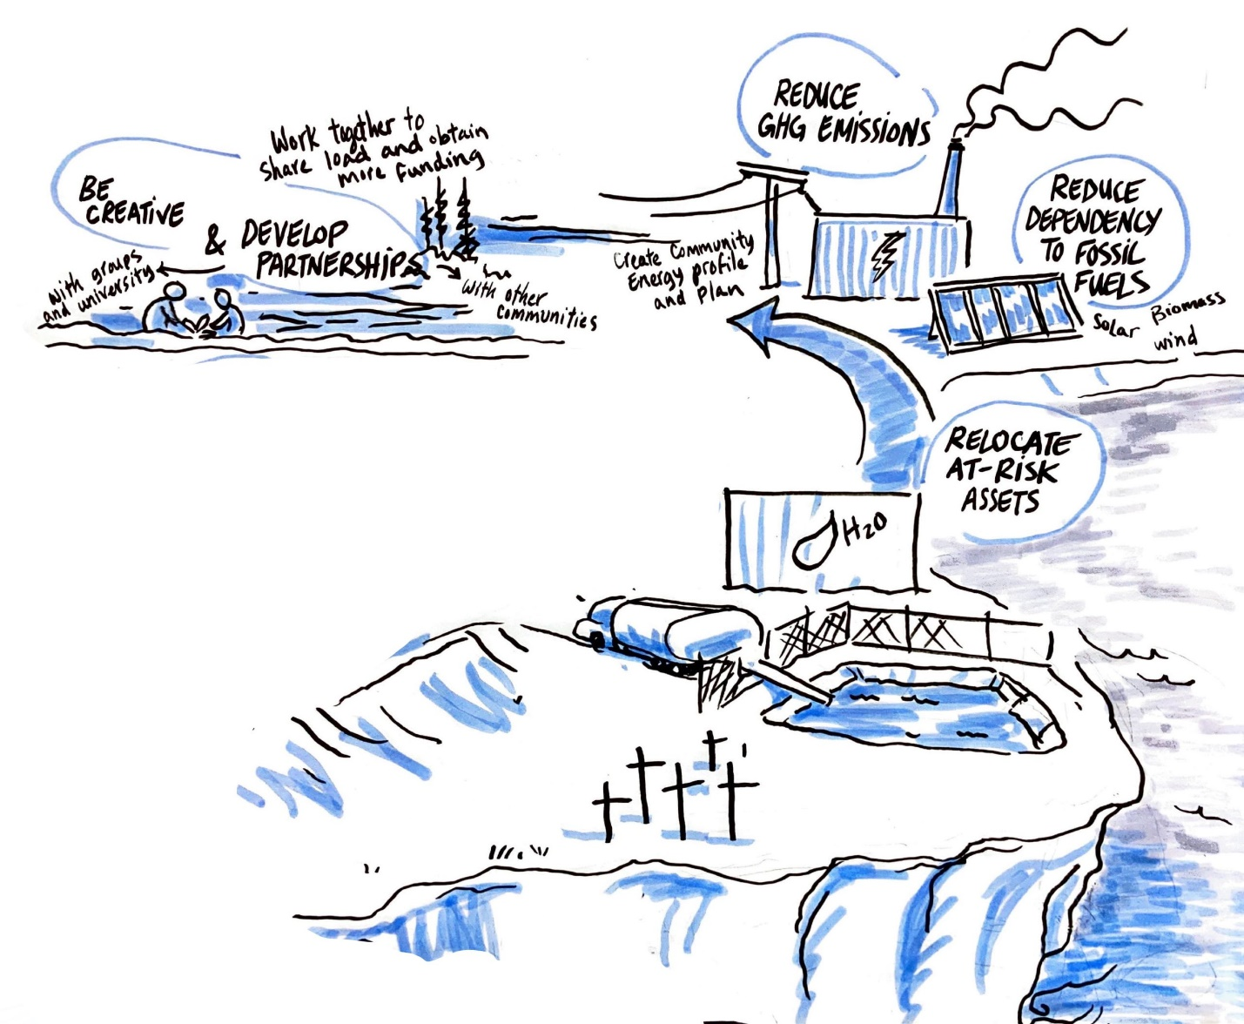
- Actions for Implementation
This step involves preparing and implementing a plan for taking action to reduce your community’s climate vulnerabilities.
Start by giving everyone 3-5 stickers (ideally round dots, but any stickers will work). Then, using a list of all of the potential vulnerabilities allow each person to select the ones they feel are most urgent or important. The top 3-5 collective items will be your focus in an action plan or roadmap.
Create a poster of your action plan so this can be kept in a central place for ease of reference, and for tracking achievements as actions are completed. The template below can be used as a starting point.
Most Urgent Vulnerability #3 Preferred Action Timeline Champion Resources
Most Urgent Vulnerability #2 Preferred Action Timeline Champion Resources
(eg. relocate community centre into retrofitted arena; undertake feasibility study for retrofit)
(eg. community centre relocation working group; grant for retrofit)
(eg. Chair of infrastructure committee)
(eg. 1 year)
…
(eg. community centre located too close to eroding rivers edge; this is also our community’s emergency centre)
Most Urgent Vulnerability #1 Preferred Action Timeline Champion Resources
Adaptation Roadmap
An example is shown below, which was an outcome of the charrette that took place as part of the 2018 Climate Change Forum to assist communities in moving from a reactive to an adaptive mindset.
Example Roadmap – Sahtu (2018)
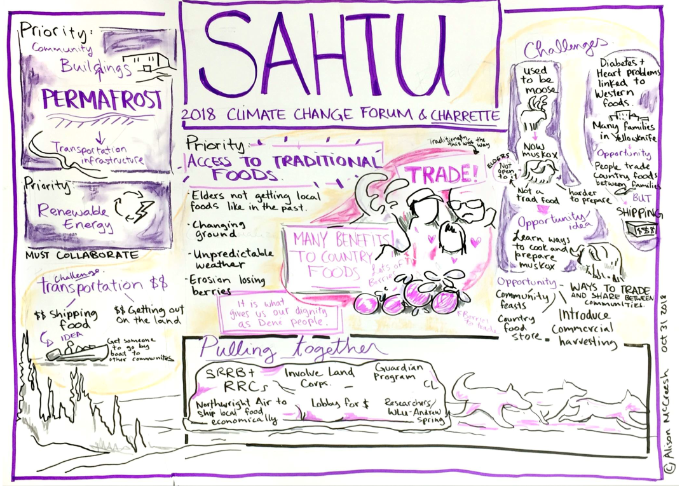
Source: NWTAC-Climate-Change-Strategic-Plan-June-20-2019.pdf (toolkitnwtac.com)

