Contents
Executive Summary i
Glossary of Terms 1
1. Introduction 4
About Asset Management 4
Considering Climate Change in Asset Management 2
Asset management Strategic Alignment 2
Asset Management Plan Structure 3
2. Current State of Assets 4
Asset Information 4
Asset Renewal 4
Community-Wide 5
Water 6
Sewer 7
Roads and Drainage 8
Buildings 9
Recreation 10
Vehicles 11
Heavy Mobile Equipment 12
Summary 13
3. Levels of Service 14
Summary 14
4. Asset Criticality and Risk 15
Criticality 15
Climate Vulnerabilities 15
Risk Assessment 15
5. Key Issues and Options 17
Key Issues 17
Options 17
6. Cost Requirements 18
Current Annual Revenue 18
O&M Costs 18
Existing Debt Servicing 19
Reserves 19
Renewal Projects 19
Non-Renewal Projects 20
Summary 21
7. Optimization Strategies 23
Risk Acceptance 23
Maintenance Management 23
Levels of Service Adjustment 23
Extending Timelines 24
Scope Change 24
Utilizing Loans or Reserves 24
Revenue Alternatives 24
Summary 24
8. Long Term Financial Plan 26
Optimized Plan 26
Managing the Sustainability Gap 27
9. Conclusions 28
Key Findings 28
Recommendations for Implementation 28
Figures
Figure 1: Elements of Asset Management 4
Figure 2: NWT Asset Management Framework 2
Figure 3: AMP Structure 3
Figure 4: Preliminary 25 Year Asset Renewal Schedule 4
Figure 5: 25 Year Schedule of Non-Renewal Projects 21
Figure 6: 25-Year Unoptimized Plan 22
Figure 7: 25-Year Optimized Plan 27

Tables
Table 1: Key Issues – Current State of Assets 13
Table 2: Levels of Service Commitments and Performance 14
Table 3: Key Issues – Levels of Service 14
Table 4: High Criticality Assets 15
Table 5: Key Climate Vulnerabilities 15
Table 6: Key Issues – Risk Assessment (Medium, High) 16
Table 7: Priority Key Issues Summary 17
Table 8: Options to Address Key Issues 17
Table 9: Current Annual Revenue 18
Table 10: O&M Costs 19
Table 11: Annualized Renewal Program 20
Table 12: Projected Non-Renewal Costs 20
Table 13: Estimated Cost Requirement Summary 21
Table 14: Optimization Actions 25
Table 15: Optimized Cost Requirement Summary 26
Appendices
Appendix A: Asset Criticality and Risk Assessment Results
Appendix B: Key Issues and Options Spreadsheet
Appendix C: Long Term Financial Plan Project List

Executive Summary
Scope and Purpose
The (Community)‘s Asset Management Plan (AMP) is a prioritized, strategic plan for managing the full lifecycle of the physical assets we own. These assets enable us to deliver services to the community. This AMP focuses on core assets across all major categories, including:

- water;
- sewer;
- roads and drainage;
- buildings;
- recreation;
- vehicles; and,
- heavy mobile equipment
- other (adjust whole list as necessary).

This AMP provides a long-term perspective to support decision making regarding our services and the assets that support them. Developing the AMP involved assessing the current state of assets, identifying risks (including climate risks), evaluating service levels, and prioritizing renewal and non-renewal projects to address key issues identified in delivering services. The outcome is an optimized long term financial plan and recommendations for taking a more proactive and sustainable approach to delivering services into the future. The AMP is an initial strategy for implementation to be refined further over time.
The AMP has been structured to answer the seven key elements of asset management and aligns with Asset Management Framework established in partnership by the Northwest Territories Association of Communities and Government of Northwest Territories’ Municipal and Community Affairs.
Current State of Assets
The (Community) delivers services to approximately (population) residents across a land base of (area) ha. The (Community) is responsible for ($00 million) in community-owned assets that enable the provision of core services including clean water, sanitation, transportation, recreation and more.
(import figure from inventory spreadsheet)
Over (percentage of total value for the asset category with the highest replacement cost) of these assets, by value, are associated with the (system name with the highest replacement value).
Community-owned assets have an average age of (average age) years, with (percentage remaining life) % of their expected useful life remaining. (describe impact that climate change is having on life expectancy of assets, even if it’s qualitative)
System-Wide Replacement Value
Key issues identified include:
- Data Availability – (describe data availability issues)
- Data Reliability – (describe data reliability issues)
- Asset Condition and Remaining Life – (describe asset condition and remaining life issues)
- (Other) – (describe)
Levels of Service
Service level commitments have been documented for each asset category to guide service delivery and measure performance. Levels of service include both legislated requirements (e.g., water quality testing) and other commitments that have been defined by (Community) staff and council, with input from the public.
The table below outlines service level commitments that are not currently being met and require action to address service deficiencies.
Levels of Service (adjust table rows as necessary based on asset categories where there is a current gap. Note that there can be more than one indicator per category)
Asset Category | Type | Levels of Service | Current Performance
(individual asset category) | (Regulatory/ Non-Regulatory) | (describe) | (met/unmet)
Notes:
1.
Key issues identified include:
- Level of Service Definition – (describe key issues)
- Performance Gaps (Regulatory) – (describe key issues)
- Performance Gaps (Non-Regulatory) – (describe key issues)
- (Other) – (describe)
Asset Criticality and Risk
Understanding the criticality and risk of community assets helps inform priorities for asset renewal and replacement. Results from the criticality and risk assessments completed as part of this AMP are summarized below and detailed in Section 4.

The (Community)’s most critical assets include:
- (List)

The (Community)’s key climate vulnerabilities include:
- (List)

Based on the risk assessment, events identified as ‘high’ or ‘very high’ risk include:
- (List)

Key Issues and Options
Projects (capital works as well as studies) were identified to address key issues identified in Sections 2, 3, and 4. These projects include both renewal and non-renewal projects for priority key issues only. The table below lists all defined projects which have been used as the basis for developing the long term financial plan.
Options to Address Key Issues
Issue No. | Options
(Issue #) | (project name)
Notes:
1.
Cost Requirements
The total cost of projects identified to address key issues is ($00 million) over the next 25 years. This is the cost for the unoptimized long term financial plan and includes ($00 million) for renewal projects and ($00 million) for non-renewal projects including new capital and studies. It also includes annual costs for already committed debt servicing, reserve contributions, and O&M and administration.
A complete list of projects is included in Section 6. The annualized cost for completing these projects, when divided over the next 25 years, is ($00 million) for renewal and ($00) for non-renewal projects.
The table below summarizes the average cost requirements on an annual basis for completing all proposed projects over the next 25 years (from Section 5), in comparison to current revenue, to determine the (surplus/shortfall).
The Figure below shows the unoptimized 25 year plan, highlighting the sustainability gap which is the difference (shortfall) between annual expenses and revenues.
25-Year Unoptimized Plan
Optimization Strategies
An optimized Long Term Financial Plan was developed through a series of working sessions with staff and council to maximize the value of community assets. Optimization strategies used to help balance the plan include:
- increasing risk acceptance for selected non-critical assets, resulting in the delay of some renewal projects and some new capital projects (specify which assets);
- developing maintenance management strategies to maximize the life of existing assets;
- adjusting level of service commitments for (describe which service areas);
- extending timelines for construction of new capital projects and renewal projects (specify which) to spread costs over time;
- adjusting project scope to leverage efficiencies and address multiple key issues;
- establishing a reserve to support future renewal spending; and
- pursuing funding opportunities to (describe any relevant projects).
(adjust whole list as necessary)

Long Term Financial Plan
The proposed Long Term Financial Plan outlines projects proposed to address key issues over the next 25 years. The Plan is based on the optimization strategies outlined in Section 7, which balance priority key issues with approaches to delivering services in a way that will be sustainable over the long term. The table below outlines details of the optimized plan.
Optimized Cost Requirement Summary
Requirement | Annual
Current Annual Revenue
Own Source Revenue | ($00)
Community Public Infrastructure Funding | ($00)
Projected Annual Expenses
O&M | ($00)
Existing Debt Servicing | ($00)
Renewal (annualized) | ($00)
Non-Renewal (annualized) | ($00)
Surplus (Shortfall) | (revenue - expenses)
Notes:
1.
The chart below shows the proposed long term financial plan, including the sustainable reinvestment rate to accommodate full lifecycle costs. The remaining sustainability gap is ($00 million). This gap is considered manageable in the short term and will be addressed through ongoing optimization to balance costs associated with future projects.
25-Year Optimized Plan
Conclusions
Key findings from (Community)‘s asset management analysis are summarized below along with recommendations for implementing this AMP. Moving forward with these recommendations will enable (Community) to take important steps towards managing the full lifecycle of our assets and delivering sustainable services into the future.

Key Findings
- (List)

Recommendations
- (List)

Glossary of Terms
The following list defines key terms used throughout the report:
Asset Category
Also referred to as asset classes, these are major infrastructure groupings by system type. Different communities have different types of assets. Typical asset categories include water, sewer, roads and drainage, buildings, recreation, vehicles, and heavy equipment. Other categories could include solid waste, cemetery, airport, protective services, and IT.
Asset Management
Asset management is an integrated process for making informed decisions, considering the present and future needs of users and the services being provided.
Asset Management Plan (AMP)
A document that describes how one or more groups of assets are to be managed over a period of time in order to deliver an agreed upon standard of service.
Asset
A physical component that has value, enables services to be provided, and has an economic life of greater than 12 months. This is also referred to as a tangible capital asset (TCA).
Asset Renewal
Capital works including major upgrades, refurbishment, or replacement of existing infrastructure with that of equivalent capacity or performance capability (i.e., bringing the asset to as near new condition as possible).
Annualized Replacement Value
The average cost for renewing an asset (or group of assets) where cost is divided over the next 25 years, or over the full life expectancy of the asset.
Capital Plan
A summary of the major and minor projects that involve restoration of capacity or function (deﬁciencies), replacement or rehabilitation of existing assets at the end of their life (renewal), system expansion (growth), or addressing other changes to the level of service being provided, such as changes in strategic direction corporately, or shifts in regulation or industry standards (levels of service).
Condition
A snapshot in time of an asset's current state of repair.
Consequence
The magnitude of impact that a possible event or scenario has considering the ﬁnancial, social and/or environmental effects. This is one of the two criteria used in assessing risk.

Criticality
The relative importance of an asset in providing community services (i.e. the severity of the consequence from an asset’s failure or loss of function).
Facility Condition Index (FCI)
A measure of a building's condition, calculated by dividing the cost requirements (cost to correct current deﬁciencies) by the current replacement value of the asset.
Historical Cost
The original cost paid to purchase or construct an asset. Where this information is unavailable, an estimate can be made using the replacement value and the Consumer Price Index (CPI)/Engineering News Record (ENR).
Infrastructure
Assets that are generally made up of components to form complex systems (e.g. water systems, sewer systems, roads networks, drainage systems, and buildings).
Inventory
A record of key information about individual community-owned assets, and the collective systems they make up, including key attributes to support decision-making (e.g. age, material, size, condition, etc.).
Level of Service
The level of service the municipality actually delivers to its customers. This measure reﬂects the quality or quantity of a given service for a particular asset category.
Level of Service Commitment
The level of service the municipality aims to deliver to its customers.
Lifecycle
The stages an asset passes through during its useful life (e.g., construction » operations and maintenance » replacement).
Likelihood
The statistical probability or frequency of a possible event or scenario, typically considered within the lifespan of an asset. This is one of the two criteria used in assessing risk.
Long Term Financial Plan
A plan to fund a community's long-term (20+ year) capital and operating needs by balancing these costs with available revenue, considering risk, criticality, levels of service and maintenance practices.
Maintenance Management
A systematic approach to repairing and undertaking preventative work to optimize asset life expectancies, manage risks and sustain target service levels.
Non-Renewal Capital Projects
Projects designed to increase current levels of service, e.g. through upgrading or expanding existing assets, conducting studies or assessments, or building new assets.
Performance Measure
The means used to assess a level of service (e.g. direct measurement, customer survey, complaint, internal review).
Replacement Cost/Value
The funds required if an asset had to be renewed or replaced, in today's dollars.
Remaining Life
The number of remaining years in which an asset is expected to continue to be functional. When calculated simply, this is based on the attributes of an asset, its expected useful life, and current age. A more accurate estimate would be based on observed asset condition.
Cost Requirement
Summarizes expenses, which is sometimes referred to as revenue requirements, consisting of capital (renewal and new works), debt servicing, operational and maintenance activities.
Risk
The potential for undesirable outcomes resulting from an incident, event, or occurrence. This is made up of the consequence and likelihood of asset failure or service disruption.
Sustainability Gap
The difference between revenue available over the long term and associated expenses in order to continue providing community services at a defined level. This is often annualized for comparison purposes.
Tangible Capital Asset (TCA)
As stated in PS 3150, tangible capital assets are non-financial assets having physical substance that:
- are held for use in the production or supply of goods and services, for rental to others, for administrative purposes or for the development, construction, maintenance, or repair of other tangible capital assets;
- have useful economic lives extending beyond an accounting period;
- are to be used on a continuing basis; and
- are not for sale in the ordinary course of operations.

Introduction
The (Community) delivers services to approximately (population) residents across a land base of (area) ha. The (Community) is responsible for ($00 million) in community-owned assets that enable the provision of core services including clean water, sanitation, transportation, recreation and more.
This Asset Management Plan (AMP) is a prioritized, strategic plan for managing the full lifecycle of the physical assets owned by the (Community) and used to deliver services. Contracted services are not included in this AMP.
Asset Management Plan Scope
The AMP focuses on core assets across all major asset categories in the community, including:

- water;
- sewer;
- roads and drainage;
- buildings;
- recreation;
- vehicles;
- heavy mobile equipment; and
- other (adjust whole list as necessary).

This AMP provides a long term perspective to support decision making regarding our services and the assets that support them. It includes a framework, strategy, and plan for asset management across the organization that is based on the best available information about community assets, drawn from the (Community)’s asset inventory.
Developing the AMP involved assessing the current state of assets, identifying risks, evaluating service levels, and prioritizing renewal and non-renewal projects to address key issues identified in delivering services. The outcome is an optimized Long Term Financial Plan (LTFP) and recommendations for taking a more proactive and sustainable approach to delivering services into the future. The AMP is an initial strategy for implementation to be refined further over time.
The AMP is grounded in regional, national, and international best practices and is the result of collaboration across departments to ensure alignment with the (Community)’s other asset management initiatives and service goals.

About Asset Management
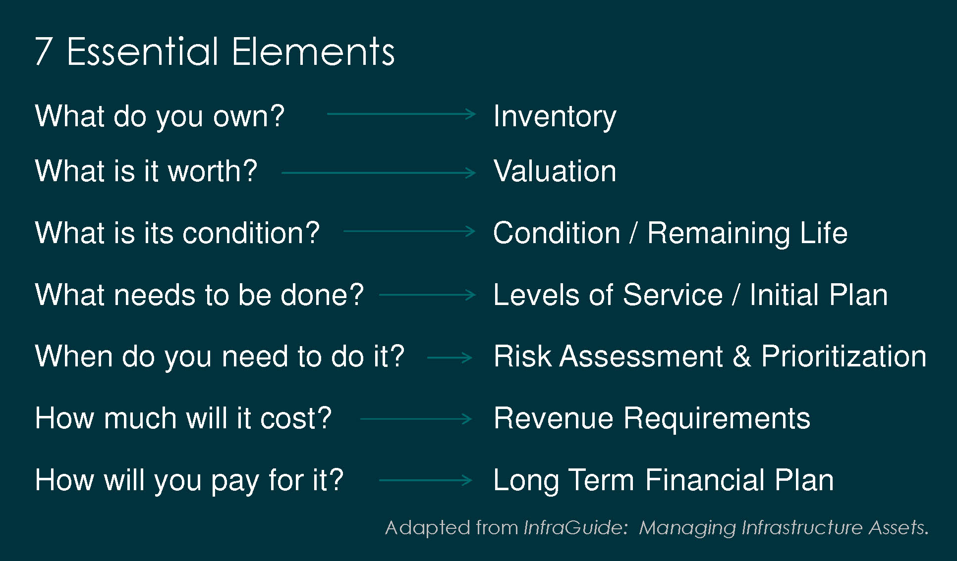
Asset management is about the delivery of core services to those that live and work in the community. It provides an integrated process for making informed decisions, considering the present and future needs of users and services they provide. Understanding the full lifecycle costs of community assets is essential.
The elements of asset management are commonly presented as questions which relate to key components of any community’s asset management program.
Figure 1: Elements of Asset Management
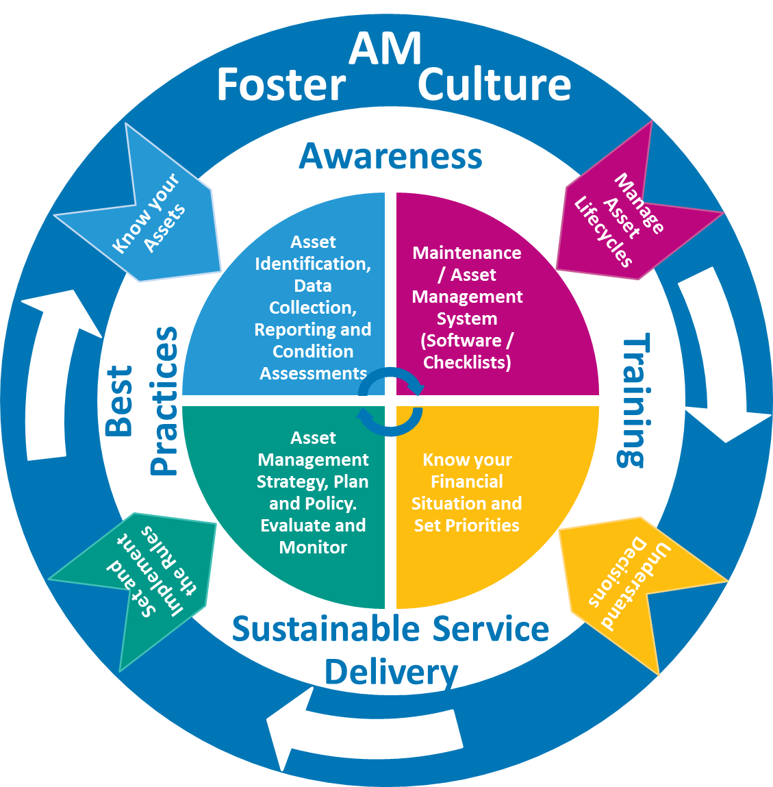
Figure 2: NWT Asset Management Framework
Figure 1 describes these elements. The (Community)’s AMP provides information on each of these seven essential elements of asset management, as described in the report sections below.
An AMP is a core component of the Asset Management Framework established by the Government of the Northwest Territories’ Municipal and Community Affairs (MACA) in collaboration with the Northwest Territories Association of Communities (NWTAC) and community governments. This Framework is shown in Figure 2.

Considering Climate Change in Asset Management
In the North, the climate is warming at approximately 4 times faster than the rest of the world. This has, and will continue to, challenge our ability to deliver essential and relied upon services to our community. The climate hazards that our community experiences include (List each hazard). As we consider climate change as part of our asset management program, it provides an avenue for becoming more resilient and ultimately sets a path forward for how we can continue delivering services to future generations.

Asset Management Strategic Alignment
The Northwest Territories Community Government Accountability Framework identifies AMPs as one of twelve indicators that will be used in measuring the performance of individual communities. This AMP reflects these commitments and is designed to align with the NWT Asset Management Framework.
The AMP is designed to support implementation of the Asset Management Policy (refer to the Asset Management Policy template and guide resource) and is integrated with other features of the (Community)’s asset management program. The AMP is aligned with the (Community)’s overarching vision, associated policies, and plans, including:
- (list plans, policies, reports)

Asset Management Plan Structure
The AMP serves as a mechanism for transparent and informed decision-making about community assets. It summarizes key information about the assets (Community) owns, operates and maintains. Key issues such as information gaps or service deficiencies have been highlighted to inform priorities for asset investments. Ultimately these key issues serve as the basis for developing options and a financial plan to support the ongoing delivery of essential community services.
The relationship between each section in the AMP is illustrated in Figure 3. Information and analysis outcomes from the earlier sections (1-4) are carried through subsequent sections (5-6), resulting in a LTFP that is both affordable and practical. The process is iterative, as illustrated by the arrow. This AMP is also a living document, meaning that it has been designed to evolve as the (Community)’s asset management program advances.
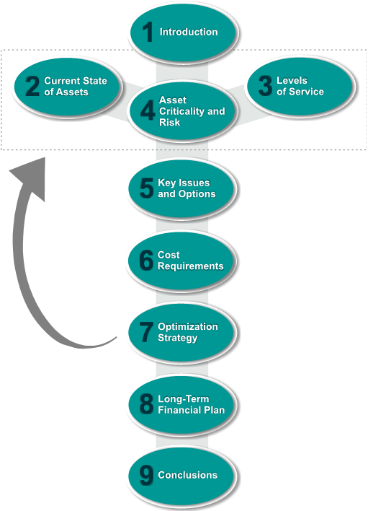
Figure 3: AMP Structure

Current State of Assets
The (Community) is responsible for assets that provide a range of essential community services, such as clean water, sanitation, and recreation. At its core, asset management is about sustainable service delivery, which directly affects quality of life.
Identifying and analyzing the current state of community assets answers the following questions: ‘What do you own?’ ‘What is it worth?’ and ‘What is its condition?’. It also helps to answer part of the question regarding ‘What needs to be done?’ specifically for the renewal of existing assets. This information has made it possible to identify key issues, or areas requiring investment to continue delivering services to the community.

Asset Information
The accuracy of our AMP relies on the quality information about our assets. Major gaps and uncertainties in asset information include:
- (list gaps and uncertainties; depending on detail this could be organized by asset category)

Asset Renewal
All of the (Community)‘s assets have been evaluated according to their expected remaining life. Wherever possible, this has been based on asset condition. Alternately, a calculated remaining life according to standard life expectances for the asset’s characteristics has been used. Figure 4 illustrates the preliminary 25 year asset renewal schedule (unadjusted for risk, levels of service and other factors).
(import figure from inventory spreadsheet)
Figure 4: Preliminary 25 Year Asset Renewal Schedule

Community-Wide
(community photo) |  | Replacement Value by Asset Type  Annualized Replacement Value: $(#)  (import figure from inventory spreadsheet)

Asset Category |  | Condition Assessment |  | Remaining and Expected Useful Life by Category
Water |  | Sample: good condition |  | (import figure from inventory spreadsheet)
Sewer |  | Sample fair condition
Roads and Drainage |  | Sample poor condition
Buildings |  | Sample unknown cond
Recreation |  | condition rating & colour
Vehicles |  | condition rating & colour
Heavy Mobile Equipment |  | condition rating & colour

Water
The (Community)’s water system provides potable water through (describe at a high level the system or service; could alternately list the number of residents and businesses serviced). The system includes community buildings and heavy equipment that provide water services (e.g. WTP, Water Truck).
Asset Inventory
Water Assets |  | Quantity |  |  |  | Replacement Value by Asset Type – Water  Remaining and Expected Useful Life by Subcategory – Water  (import figure from inventory spreadsheet)
(Subcategory) |  | (#)
 |  |  |  |  |  | (import figure from inventory spreadsheet)
Total Replacement Value: $ (#) million
Annualized Replacement Value: $ (#)
Average Age: (#) years
Average Estimated Remaining Life: (#) %
Average Condition: |  |  | condition rating & colour
Insert Photo | Insert Photo |  |  | Insert Photo |  |  | Insert Photo | Insert Photo

Sewer
The (Community)’s sewer system provides sanitation through (describe at a high level the system or service; could alternately list the number of residents and businesses serviced). The system includes community buildings and heavy equipment that provide sewer services (e.g. Lift Station, Sewer Truck).
Asset Inventory
Sewer Assets |  | Quantity |  |  |  | Replacement Value by Asset Type – Sewer  Remaining and Expected Useful Life by Subcategory - Sewer  (import figure from inventory spreadsheet)
(Subcategory) |  | (#)
 |  |  |  |  |  | (import figure from inventory spreadsheet)
Total Replacement Value: $(#) million
Annualized Replacement Value: $(#)
Average Age: (#) years
Average Estimated Remaining Life: (#)%
Average Condition: |  |  | condition rating & colour
Insert Photo | Insert Photo |  |  | Insert Photo |  |  | Insert Photo | Insert Photo

Roads and Drainage
The (Community)’s roads and drainage network provide mobility and stormwater management through (describe at a high level the system or service; could alternately list the number of residents and businesses serviced).
Asset Inventory
Road and Drainage Assets |  | Quantity |  |  |  | Replacement Value by Asset Type – Road and Drainage  Remaining and Expected Useful Life by Subcategory – Roads and Drainage  (import figure from inventory spreadsheet)
(Subcategory) |  | (#)
 |  |  |  |  |  | (import figure from inventory spreadsheet)
Total Replacement Value: $(#) million
Annualized Replacement Value: $(#)
Average Age: (#) years
Average Estimated Remaining Life: (#)%
Average Condition: |  |  | condition rating & colour
Insert Photo | Insert Photo |  |  | Insert Photo |  |  | Insert Photo | Insert Photo

Buildings
The (Community)’s buildings house services such as (describe at a high level the system or service). This section excludes the buildings related to water, sewer and recreation assets which have been included in their respective sections above and below. (could alternately list the number of residents and businesses serviced)
Asset Inventory
Buildings Assets |  | Quantity |  |  |  | Replacement Value by Asset Type – Buildings  Remaining and Expected Useful Life by Subcategory - Buildings  (import figure from inventory spreadsheet)
(Subcategory) |  | (#)
 |  |  |  |  |  | (import figure from inventory spreadsheet)
Total Replacement Value: $(#) million
Annualized Replacement Value: $(#)
Average Age: (#) years
Average Estimated Remaining Life: (#)%
Average Condition: |  |  | condition rating & colour
Insert Photo | Insert Photo |  |  | Insert Photo |  |  | Insert Photo | Insert Photo

Recreation
The (Community)’s indoor and outdoor recreation assets provide facilities for (describe at a high level the system or service; could alternately list the number of residents served). Recreational assets include community buildings associated with recreation (e.g. Arena, Recreation Complex).
Asset Inventory
Recreation Assets |  | Quantity |  |  |  | Replacement Value by Asset Type – Recreation  Remaining and Expected Useful Life by Subcategory - Recreation  (import figure from inventory spreadsheet)
(Subcategory) |  | (#)
 |  |  |  |  |  | (import figure from inventory spreadsheet)
Total Replacement Value: $(#) million
Annualized Replacement Value: $(#)
Average Age: (#) years
Average Estimated Remaining Life: (#)%
Average Condition: |  |  | condition rating & colour
Insert Photo | Insert Photo |  |  | Insert Photo |  |  | Insert Photo | Insert Photo

Vehicles
The (Community)’s vehicles (and light mobile equipment) enable internal and external services including (describe at a high level the services being provided, whether internal or external). Specialized water, sewer and recreation vehicles and equipment are included in their respective categories above.
Asset Inventory
Vehicles Assets |  | Quantity |  |  |  | Replacement Value by Asset Type – Vehicles  Remaining and Expected Useful Life by Subcategory - Vehicles  (import figure from inventory spreadsheet)
(Subcategory) |  | (#)
 |  |  |  |  |  | (import figure from inventory spreadsheet)
Total Replacement Value: $(#) million
Annualized Replacement Value: $(#)
Average Age: (#) years
Average Estimated Remaining Life: (#)%
Average Condition: |  |  | condition rating & colour
Insert Photo | Insert Photo |  |  | Insert Photo |  |  | Insert Photo | Insert Photo

Heavy Mobile Equipment
The (Community) ’s heavy mobile equipment enables internal and external services including (describe at a high level the services being provided, whether internal or external). Specialized heavy equipment for water, sewer and recreation purposes are included in their respective categories above.
Asset Inventory
Heavy Mobile Equipment Assets |  | Quantity |  |  |  | Replacement Value by Asset Type – Heavy Mobile Equipment  (import figure from inventory spreadsheet)  Remaining and Expected Useful Life by Subcategory – Mobile Heavy Equipment
(Subcategory) |  | (#)
 |  |  |  |  |  | (import figure from inventory spreadsheet)
Total Replacement Value: $(#) million
Annualized Replacement Value: $(#)
Average Age: (#) years
Average Estimated Remaining Life: (#)%
Average Condition: |  |  | condition rating & colour
Insert Photo | Insert Photo |  |  | Insert Photo |  |  | Insert Photo | Insert Photo

Summary
Information about the state of assets in (Community) has been assessed to reveal information gaps and potential asset renewal needs over the next 25 years. These key issues are summarized in Table 1 and will inform the development of options in Section 5 of this AMP, and ultimately the (Community)’s long-term financial plan in Section 8.
Table 1: Key Issues – Current State of Assets
Issue (Item) | Key Issue | Description
2.1 | Data Quality | (Describe)
2.2 | Asset Condition
2.3 | Remaining Life
(2.X) | (List)

Levels of Service
This section begins answering the question ‘what needs to be done?’. It outlines level of service commitments and tracks the (Community)’s performance in meeting these commitments.
While some levels of service are legally required (regulatory), others have been defined by the (Community) to guide service delivery (non-regulatory). Table 2 outlines levels of service commitments by asset category and the (Community)’s recent performance.
Table 2: Levels of Service Commitments and Performance
Asset Category | Level of Service Commitment | Type | Reference | Current Performance
(Asset Category) | (Describe) | (Regulatory/ Non-Regulatory) | (Regulation No.) | (Met/Not Met)
Notes:
1.

Summary
An assessment of (Community)’s performance against established level of service commitments has revealed some gaps in service delivery. These gaps are noted as key issues summarized in Table 3 and will inform the development of options in Section 5 of this AMP, and ultimately the (Community)’s LTFP in Section 8.
Table 3: Key Issues – Levels of Service
Issue (Item) | Key Issue | Description
3.1 | Level of Service Definition | (Describe)
3.2 | Performance Gaps – Regulatory
3.3 | Performance Gaps – Non-Regulatory
(3.X) | (List)
Notes:
1.

Asset Criticality and Risk
Understanding the criticality and risk of community assets helps answer the question ‘what needs to be done?’ and ‘when do you need to do it?’. The outcome of this process has informed the prioritization of asset renewal projects that are included in the LTFP.

Criticality
The criticality of an asset is its relative importance for providing critical community services, which is often linked with the severity of the consequence from an asset’s failure or loss of function. While the loss of some facilities or systems would have little impact on service delivery and negligible risk of injury, the loss of others would severely impact services and may lead to fatalities or heavy financial losses. This assessment of criticality has been done for (Community)’s assets.
A criticality rating has been established based on a three-point scale: low, medium, high. Assets identified with a high criticality are listed in Table 4.
Table 4: High Criticality Assets
Critical Asset  (Asset Name) | Description of Criticality
(Asset Name) | (Describe)
Notes:
1.

Climate Vulnerabilities
A major type of risk facing our community is from a changing climate. We are already taking measures to reduce, or eliminate some of our community’s climate vulnerabilities including (Describe actions already being taken to address vulnerabilities). The top remaining vulnerabilities to our services and/or systems are described in Table 5 (List 2-3 in the table below).
Table 5: Key Climate Vulnerabilities
Services/Systems  (Name) | Vulnerabilities to Climate Hazards
(System/Service Name) | (Describe)
Notes:
1.

Risk Assessment
The risk assessment in this AMP is based on a qualitative analysis of the likelihood and consequence of identified risks including asset loss or failure. This includes, but is not limited to, risks from a changing climate. The risk of each asset was rated on a three-point scale: low, medium, high. Details on the risk methodology used is provided in Appendix A.
High risk assets have been identified as key issues as shown in Table 6. The results from this risk assessment inform the process for prioritizing asset renewal. Detailed tables used in identifying and assessing risk are included in Appendix A.
Table 6: Key Issues – Risk Assessment (Medium, High)
Issue (Item) | Event | Impacted Asset(s) | Risk Rating
4.1 | (Describe event – what could happen?) | (List assets affected – start with your most critical assets) | (Medium, High)
(4.X)
Notes:
1.

Key Issues and Options
This section answers the question ‘what needs to be done?’ and ‘when do you need to do it?’ This Section brings together the most significant key issues identified in Sections 2 – 4 and proposes options for addressing each issue. These key issues have been compiled and prioritized through input from staff. Options developed to address these priorities serve as the foundation for long term financial planning in this AMP.

Key Issues
Key issues identified throughout the AMP have been compiled and prioritized by (Community) staff. Priority issues are listed in Table 7, with the full list of key issues provided in Appendix B.
Table 7: Priority Key Issues Summary
Issue (Item) | Key Issue | Priority Description | Priority
(X.X) | (List – from Section 2, 3, 4) | (Describe why identified as a priority) | (Medium, High)
Notes:
1.
(Describe identified priorities, approximately one paragraph per priority)

Options
Strategies to address priority key issues have been developed based on an evaluation of potential options. (Include date if workshop was held to develop and prioritize options). These options include capital renewal projects, new capital, as well as further studies, assessments, and reporting initiatives. Preferred options are outlined in Table 8, with further detail provided on each project and alternatives in Appendix B.
Table 8: Options to Address Key Issues
Issue (Item) | Preferred Option | Description | Project Type | Timeframe | Cost
(X.X) | (List) | (Describe) | Renewal/ Non-Renewal | (Year) | ($-$$$$)
Notes:
1.

Cost Requirements
This section answers the question ‘how much will it cost?’ It considers current revenue and expenses including addressing the key issues identified in Section 5.
Cost requirements consider current revenue, operations and maintenance (O&M), debt servicing, reserve funds, renewal (eg. replacing existing capital or undertaking condition assessments), and non-renewal (e.g. new capital works or undertaking studies) costs over both the short and long term. Anticipated new capital investments are considered from a full lifecycle perspective and then factored in and compared to the community’s current spending in these areas.
The annual cost requirement for all existing community assets is ($00 million), including ($00 million) for capital renewal, and ($00 million) for operation and maintenance. This is based on a 25-year plan, using 2018 dollars.

Current Annual Revenue
(Community)’s current annual revenue to support the delivering of community services is ($00) and is made up of general revenue, water revenue and sewer revenue from property taxes where applicable, fees and charges, special levies, government infrastructure funding, and reserves. Current annual revenue, as it relates to supporting both capital works and the administration, operations and maintenance of infrastructure, is shown in Table 9.
Table 9: Current Annual Revenue
Revenue Source¹ | Annual Revenue
Own Source Revenue
General Revenue | ($00)
Water Revenue | ($00)
Sewer Revenue | ($00)
Community Public Infrastructure Funding
Operations and Maintenance | ($00)
Capital | ($00)
Subtotal | ($00)
Notes:
1. Specifically the revenue that is available for capital works as well as administration, operations and maintenance of infrastructure.

O&M Costs
O&M costs refer to ongoing and repeated annual costs incurred to keep all systems in working order. This includes all costs required in providing services except for those that are related to acquisition, renewal, or disposal of assets. Administration related to O&M is also included. O&M costs fluctuate each year, as illustrated based on a view of the last five years shown in Table 10. Annual O&M costs are estimated at ($00) on average per year. Looking forward, this is the projected annual O&M portion of the cost requirement prior to factoring in the increased costs associated with climate change (which have currently been excluded from this AMP).
Table 10: O&M Costs
Cost Category | Estimated O&M Cost
 | (year 5 – eg. 2014) | (year 4 – eg. 2015) | (year 3 – eg. 2016) | (year 2 – eg. 2017) | (year 2 – eg. 2018) | Average
Wages and Benefits | ($00) | ($00) | ($00) | ($00) | ($00) | ($00)
Equipment Use | ($00) | ($00) | ($00) | ($00) | ($00) | ($00)
Utilities | ($00) | ($00) | ($00) | ($00) | ($00) | ($00)
Materials and Supplies | ($00) | ($00) | ($00) | ($00) | ($00) | ($00)
Contracted Services | ($00) | ($00) | ($00) | ($00) | ($00) | ($00)
Administration | ($00) | ($00) | ($00) | ($00) | ($00) | ($00)
Subtotal | ($00) | ($00) | ($00) | ($00) | ($00) | ($00)
Notes:
1.

Existing Debt Servicing
The (Community) is responsible for ($00) in existing debt servicing costs each year, on average, based on a 25 yea horizon. The interest portion of this debt servicing is ($00). In 2018 the debt servicing cost was ($00) and decreases to ($00) by 2042. (remove if not relevant, or adjust paragraph as needed)

Reserves
The (Community) administers a reserve fund for implementing future renewal projects. The total existing balance in the (Community)’s reserve fund is ($00). The (Community) transfers ($00) to this reserve fund each year when major renewal projects are not scheduled. (remove if not relevant, or adjust paragraph as needed)

Renewal Projects
The total cost for renewal projects is estimated to be ($00 million) over the next 25 years. Major renewal projects with a value greater than $1 million that are scheduled over the next 25 years include the following assets:
- (Asset name, $00 renewal cost, renewal year(s))

The annualized replacement value for all projects over the next 25 years is ($00 million), and extended over the full life expectancy of each asset is ($00 million). Annualized costs for each asset category are summarized in Table 11. The details of annual spending over the next 25 years have been drawn from Figure 4: Preliminary 25 Year Asset Renewal Schedule in Section 2. A more detailed breakdown of annualized costs within each asset category is provided in Appendix C.

Table 11: Annualized Renewal Program
Asset Category | 25 Year Replacement Cost | 25 Year Annualized Cost | Total Replacement Cost | Life Expectancy Annualized Cost
Water | ($00) | ($00) | ($00) | ($00)
Sewer | ($00) | ($00) | ($00) | ($00)
Roads and Drainage | ($00) | ($00) | ($00) | ($00)
Buildings | ($00) | ($00) | ($00) | ($00)
Recreation | ($00) | ($00) | ($00) | ($00)
Vehicles | ($00) | ($00) | ($00) | ($00)
Heavy Equipment | ($00) | ($00) | ($00) | ($00)
Subtotals | ($00) | ($00) | ($00) | ($00)
Notes:
1. Assets with missing installation date or replacement costs are not included.

Non-Renewal Projects
A total of ($00 million) is planned over the next 25 years for non-renewal projects to address key issues to service delivery. This also includes key issues (X.X, X.X etc) from Section 5 that are not related to capital renewal projects (eg. addressing data gaps and undertaking condition assessments – adjust as required).
Major non-renewal projects with a value greater than $1 million that are planned for construction/purchase over the next 25 years include the following:
- (Project name, $00, year(s) of project commencement to completion);

It should be acknowledged that capital project cost estimates, in particular, are high-level with a large margin of error. A detailed cost estimate and design will be undertaken within 3-5 years of the project being undertaken.
The annualized cost of implementing these projects over the next 25 years is ($00). These are summarized for each asset category in Table 12.
Table 12: Projected Non-Renewal Costs
Asset Category | 25 Year Total Cost | 25 Year Annualized Cost
Water | ($00) | ($00)
Sewer | ($00) | ($00)
Roads and Drainage | ($00) | ($00)
Buildings | ($00) | ($00)
Recreation | ($00) | ($00)
Vehicles | ($00) | ($00)
Heavy Equipment | ($00) | ($00)
Subtotal | ($00) | ($00)
Notes:
1.
Figure 5 shows the estimated cost and timing for implementing all non-renewal projects identified over the next 25 years. The annualized cost during this period is also illustrated.
Figure 5: 25 Year Schedule of Non-Renewal Projects

Summary
Table 13 provides a summary of the estimated cost requirements for (Community) considering all asset categories. The preliminary (surplus/shortfall) is ($00) which will be further optimized in Section 7, including consideration for drawing on available reserve funds where appropriate.
Table 13: Estimated Cost Requirement Summary
Requirement | Annual
Current Annual Revenue
Own Source Revenue | ($00)
Community Public Infrastructure Funding | ($00)
Projected Annual Expenses
O&M | ($00)
Existing Debt Servicing | ($00)
Renewal (annualized) | ($00)
Non-Renewal (annualized) | ($00)
Surplus (Shortfall) | (revenue - expenses)
Notes:
1.
Figure 6 shows the unoptimized 25-year plan, highlighting the sustainability gap which is the cumulative difference (shortfall) between annual expenses and revenues.
Figure 6: 25-Year Unoptimized Plan

Optimization Strategies
A series of optimization strategies have been considered by considering strategies to balance the question 'how much will it cost’ with the question ‘how will you pay for it’. Working towards long term financial sustainability is key. Each strategy is described below, and where appropriate, actions have been included in the LTFP (Section 8).
Revenue
Expenses
Risks | Maintenance Management
Levels of Service | Reserves | Loans

Risk Acceptance
Results from the risk assessment in Section 4 were reviewed to consider whether the (Community)’s risk tolerance should be adjusted. Adjusting risk levels includes approaches such as delaying projects or deliberately running selected assets to failure (adjust based on the risk approaches selected). The Summary subsection below outlines actions associated with accepting specific risks, along with the cost implications. (adjust paragraph depending on whether actions have been listed for risk, and if there are not any longer term recommendations for implementation)

Maintenance Management
Maintenance management has both capital as well as operations and maintenance cost implications through proactive planning, increased efficiency and innovation (eg. using alternate technologies). Adjusting maintenance practices includes approaches such as (describe based on the maintenance management approaches selected). The Summary subsection below outlines actions associated with adjusting maintenance practices, along with the cost implications. (adjust paragraph depending on whether actions have been listed for maintenance management and if there are not any longer term recommendations for implementation)

Levels of Service Adjustment
Adjusting levels of service was also considered as a way to optimize our approach to managing infrastructure. Immediate levels of service adjustments include (describe based on the LOS approaches selected). The Summary subsection below outlines actions associated with adjusting levels of service, along with the cost implications. (adjust paragraph depending on whether actions have been listed for LOS adjustments and if there are not any longer term recommendations for implementation)

Extending Timelines
Adjusting project timelines, whether by phasing projects over time or deferral, is another strategy for optimizing a LTFP to balance expenditures with available revenue. Decisions affecting timeline may increase risk or decrease levels of service to a small degree, though major decisions in these areas have been addressed in earlier sections. The opportunity to extend the initiation of, or phase, projects has been considered across all asset categories. Key adjustments include undertaking condition assessments to confirm pending renewal projects (adjust based on the timeline extensions selected). The Summary subsection below outlines actions associated with extending project timelines, along with the cost implications. (adjust paragraph depending on whether actions have been listed for timeline extensions, and if there are not any longer term recommendations for implementation)

Scope Change
Adjusting the scope of proposed projects can maximize efficiencies by minimizing required costs for administration, travel, and materials. Opportunities to adjust the scope of proposed projects to include additional components include (describe based on scope change options selected. The Summary subsection below outlines actions associated with adjusting project scope, along with cost implications. (adjust paragraph depending on whether actions have been listed for project scope changes, and if there are not any longer term recommendations for implementation)

Utilizing Loans or Reserves
Financial tools such as loans or reserves enable communities to spread out costs to create a more ‘even’ LTFP by reducing peaks in spending needs and in some cases distributing costs more equitably to both current and future users of a service. Approaches to borrowing include (describe based on the debt approaches selected). Reserves will be used to (describe based on the debt approaches selected). The Summary subsection below outlines actions associated with utilizing loans and reserves, along with the cost implications. (adjust paragraph depending on whether actions have been listed for loan and reserve adjustments and if there are not any longer term recommendations for implementation).

Revenue Alternatives
Maximizing existing revenues ensures services are delivered at the lowest sustainable cost. Immediate revenue alternatives include exploring grant funding for (describe projects and adjust based on revenue alternatives selected). The Summary subsection below outlines actions associated with applying revenue alternatives, along with the cost implications (including longer term recommendations eg. rate structure studies, increases in taxes and fees, development financing tools). (adjust paragraph depending on whether actions have been listed for revenue alternatives and if there are not any longer term recommendations for implementation).

Summary
A compiled list of actions based on the strategies noted above are presented Table 14. This includes both immediate actions considered and applied as part of this AMP (complete), as well as longer term (pending) initiatives that will be undertaken to determine if further optimization strategies can be applied. The longer term strategies have been included in Section 9 as recommendations for further implementation.
Table 14: Optimization Actions
Action | Description | Status | Impact
Risk Acceptance
(List) | (Describe) | (Pending - year, Complete) | (-$00)
Maintenance Management
(List) | (Describe) | (Pending, Complete) | (-$00)
Levels of Service Adjustment
(List) | (Describe) | (Pending, Complete) | (-$00)
Extending Timelines
(List) | (Describe) | (Pending, Complete) | (-$00)
Scope Change
(List) | (Describe) | (Pending, Complete) | (-$00)
Utilizing Debt or Reserves
(List) | (Describe) | (Pending, Complete) | (-$00)
Revenue Alternatives
(List) | (Describe) | (Pending, Complete) | (-$00)
Notes:
1.

Long Term Financial Plan
An optimized Long Term Financial Plan has been developed for (Community)-owned assets for the next 25 years. The LTFP answers the question ‘how will you pay for it?’ based on the optimization strategies outline in Section 7.
The strategies incorporated into this Plan were evaluated through a working session with (Community) staff and Council. This LTFP is the first iteration of balancing what the community needs against what it can reasonably afford by making decisions about risks, levels of service, maintenance management and financing. It is intended to bring us an important step closer to sustainable service delivery. Longer term strategies being considered are presented in Section 9 and will be incorporated into future iterations of our AMP.

Optimized Plan
The average cost over the next 25 years is ($00) annually for renewal and non-renewal projects, and ($00) for O&M over this period. Table 15 illustrates the cost implications from the optimization strategies identified in Section 7, which use the unoptimized plan from Section 6 as the basis for adjustments.
Table 15: Optimized Cost Requirement Summary
Requirement | Annual
Current Annual Revenue
Own Source Revenue | ($00)
Community Public Infrastructure Funding | ($00)
Projected Annual Expenses
O&M | ($00)
Existing Debt Servicing | ($00)
Renewal (annualized) | ($00)
Non-Renewal (annualized) | ($00)
Surplus (Shortfall) | (revenue - expenses)
Notes:
1.
Figure 7 shows the proposed long term financial plan, including the sustainable reinvestment rate over both the next 25 years and the full life expectancy of assets.
Figure 7: 25-Year Optimized Plan

Managing the Sustainability Gap
Outcomes from the optimization process created a long term financial plan that is more balanced and affordable for (Community). However, despite the strategies adopted to balance the plan, a gap still remains between our available revenue and planned expenditures under the optimized plan. This is referred to as the sustainability gap.
The total sustainability gap for the (Community)’s long term financial plan is ($00). This gap is considered manageable in the short term and will be addressed through ongoing optimization to balance costs associated with future projects.
Recommended longer term strategies to further address this sustainability gap include:
- (List)

Conclusions
The (Community)’s AMP provides a long-term perspective to support decision making regarding our services and the assets that support them. Developing the AMP involved assessing the current state of assets, identifying risks, evaluating service levels, and prioritizing renewal and non-renewal projects to address key issues identified in delivering services. The outcome is the first iteration of an optimized long term financial plan and recommendations for taking a proactive and sustainable approach to delivering services into the future. The AMP is an initial strategy for implementation and will be refined further over time. Key findings from analysis in this report are summarized below along with recommendations for implementing this AMP.

Key Findings
Key findings about the state of existing service delivery and key requirements for continuing to deliver core services into the future include the following:
- (List)

Recommendations for Implementation
The following actions are recommended to enable the (Community) to efficiently manage community-owned assets over the short and long term:
- (List)

